ACTS
SUPPLEMENT No. 4 18th March, 2011.
ACTS SUPPLEMENT
to The Uganda Gazette No. 19 Volume CIV dated 18th March, 2011.
Printed by UPPC, Entebbe, by Order of the Government.
Institution of Traditional or Cultural Act 6 Leaders Act 2011
THE INSTITUTION OF TRADITIONAL OR CULTURAL LEADERS
ACT, 2011
ARRANGEMENT OF SECTIONS
Part I—Preliminary
Section
- Commencement.
- Interpretation.
Part II—Institution of Traditional or Cultural Leader
- Existence of the institution of traditional or cultural leader.
- Institution of traditional or cultural leader.
- Installation of traditional or cultural leader.
- Publication of declaration of traditional or cultural leader.
- Capacity of institution of traditional or cultural leader.
- Publication of abdication or cessation of traditional or cultural leaders.
Part III—Role of Traditional And Cultural Leaders
- Role of a traditional or cultural leader.
Part IV—Privileges And Benefits
- Privileges and benefits of a traditional or cultural leader.
- Responsibility of the community where a traditional or cultural leader exists.
1

Act 6
Institution of Traditional or Cultural
Leaders Act
2011
Section
Part V—Restrictions on A Traditional or Cultural Leader
- Exercise of administrative, legislative or executive powers.
- Traditional or cultural leaders not to join or participate in partisan politics.
- Prohibited customs or traditions.
- Relationship with foreign governments.
Part VI—Resolution of Disputes
- Resolution of disputes.
Part VII—Miscellaneous
- Liability of traditional or cultural leaders.
- Symbols and seals of institution of traditional or cultural leaders.
- Power of Minister to amend Schedules.
- Regulations.
SCHEDULES
Schedule 1—Currency Point
Schedule 2—Privileges and Benefits of Traditional or Cultural Leaders
2

Act 6
Institution of Traditional or Cultural
Leaders Act
2011
THE INSTITUTION OF TRADITIONAL OR CULTURAL LEADERS ACT, 2011
An Act to operationalise article 246 of the Constitution on the institution of traditional or cultural leaders; to provide for the existence of traditional or cultural leaders in any area of Uganda in accordance with the Constitution; to provide for the privileges and benefits of the traditional or cultural leaders; to provide for the resolution of issues relating to traditional or cultural leaders and for related matters.
Date of Assent: 26th February, 2011.
Date of Commencement: See Section 1.
Be it enacted by Parliament as follows:
Part I—Preliminary
- Commencement.
This Act shall come into force on a date appointed by the Minister by statutory instrument.
- Interpretation.
In this Act, unless the context otherwise requires—
“court” means the High Court of Uganda;
“Constitution” means the Constitution of the Republic of Uganda;
3

Act 6
Institution of Traditional or Cultural
Leaders Act
2011
“corporation sole” means a continuous legal personality that is attributed to successive holders of certain monarchical positions such as kings;
“currency point” has the value assigned to it in schedule 1;
“institution of traditional or cultural leader” means the throne, station, status or other position held by a traditional or cultural leader and “institution” shall be construed accordingly;
“Government” means the Government of uganda;
“Minister” means the Minister responsible for culture;
“partisan politics” includes—
- promoting, or supporting a political party or political organisation or an individual in respect of political activities;
- making statements against Government or opposition policies or programs;
- making statements or comments on Bills or motions under consideration by Parliament with a view to influencing their outcome;
“privilege” means a right, advantage or immunity, conferred on a traditional or cultural leader;
“traditional or cultural leader” means a king or similar traditional leader or cultural leader by whatever name called who derives allegiance from the fact of birth or descent in accordance with the customs, traditions, usage or consent of the people led by that traditional or cultural leader.
4

Act 6
Institution of Traditional or Cultural
Leaders Act
2011
Part II—Institution of Traditional or Cultural Leader
- Existence of the institution of traditional or cultural leader.
Subject to the Constitution, the institution of traditional or cultural leader may exist in any area of Uganda in accordance with the culture, customs and traditions or wishes and aspirations of the people to whom it applies.
- Institution of traditional or cultural leader.
- A traditional or cultural leader may be instituted in the following ways—
- in accordance with the culture, customs and traditions of the people to whom it applies; or
- in accordance with the wishes and aspirations of the people to whom it applies, through a resolution of not less than two thirds of all members of the district local councils and sub county local government councils respectively in the area.
- The institution under sub section (1) shall be communicated in writing to the Minister.
- Installation of traditional or cultural leader.
- A person may be installed as a traditional or cultural leader in any area of Uganda if that person derives allegiance from—
- birth; or
- descent,
in accordance with the customs, traditions, usage or consent of the people led by that traditional or cultural leader.
- A person shall not be installed as a traditional or cultural leader unless the person derives allegiance from birth or descent in accordance with article 246(1) to (6) of the Constitution.
5

Act 6
Institution of Traditional or Cultural
Leaders Act
2011
- Subject to Article 246(3)(d) of the Constitution, a person shall not be compelled to pay allegiance or contribute to the cost of maintaining a traditional or cultural leader.
- A person who compels another person to pay allegiance to a traditional or cultural leader commits an offence and is liable on conviction to a fine not exceeding twenty four currency points or imprisonment not exceeding twelve months or both.
- Publication of declaration of traditional or cultural leader.
Where a traditional or cultural leader has been declared to exist in any area of Uganda in accordance with the culture, customs and traditions or wishes and aspirations of the people, the Minister shall cause the declaration to be published in the Gazette.
- Capacity of institution of traditional or cultural leader.
- The institution of a traditional or cultural leader is a corporation sole with perpetual succession and with capacity to sue and be sued and to hold assets or properties in trust for itself and the people concerned.
- A traditional or cultural leader may hold any asset or property acquired in a personal capacity.
- Publication of abdication or cessation of traditional or cultural leader.
Where a traditional or cultural leader—
- abdicates the institution of a traditional or cultural leader; or
- lawfully ceases to be a traditional or cultural leader,
the Minister shall cause the abdication or cessation to be published in the Gazette.
6

Act 6
Institution of Traditional or Cultural
Leaders Act
2011
Part III—Role of Traditional and Cultural Leaders
- Role of traditional or cultural leader.
A traditional or cultural leader shall—
- promote and preserve the cultural values, norms and practices which enhance the dignity and well being of the people where he or she is recognised as such; and
- promote the development, preservation and enrichment of all
the people in the community where he or she is recognized as such.
Part IV—Privileges And Benefits
- Privileges and benefits of a traditional or cultural leader.
- A traditional or cultural leader shall enjoy the privileges and benefits specified in Schedule 2.
- A traditional or cultural leader shall enjoy such privileges and benefits as may be conferred by the Government and local Government or as that leader may be entitled to under culture, custom or traditions which are not inconsistent with the Constitution or this Act or any other law.
- Where a traditional or cultural leader exists in more than one regional government, the benefits shall be paid by the regional governments in equal proportions.
- The benefits payable under this section shall be free from income tax.
- The duties and responsibilities of the traditional or cultural leader may be financed through central government from the Consolidated Fund as a grant.
7

Act 6
Institution of Traditional or Cultural
Leaders Act
2011
- Responsibility of the community where a traditional or cultural leader exists.
- The community where a traditional or cultural leader is installed shall have the primary responsibility of maintaining the traditional or cultural leader.
- Notwithstanding subsection (1), a person shall not be compelled to contribute to the cost of maintaining a traditional or cultural leader or any institution of the traditional or cultural leader.
Part V—Restrictions on A Traditional or Cultural Leader
- Exercise of administrative, legislative or executive powers.
A traditional or cultural leader shall not have or exercise any administrative, legislative or executive powers of Government or a local government.
- Traditional or cultural leaders not to join or participate in partisan politics.
- A person shall not, while remaining a traditional or cultural leader, join or participate in partisan politics.
- A traditional or cultural leader wishing to take part and seeking elective office shall abdicate his position in the institution not less than ninety days before nomination day in respect of that election.
- For the purposes of this section a person joins or participates in partisan politics when that person—
- becomes a registered member or card bearing member of the political party or political organisation;
- allows a member of a political party or political organisation or individual for purposes of political activities to articulate views, aspirations and interests of that political party or political organisation or individual;
8

Act 6
Institution of Traditional or Cultural
Leaders Act
2011
- knowingly attends a rally or debate where the views, aspirations or interests of a political party or political organisation are articulated;
- allows a person in the employment of the traditional or cultural institution of which the person is a leader to engage in any of the activities referred to in paragraphs (a) to (c).
- A person who knowingly involves a traditional or cultural leader in partisan politics commits an offence and is liable on conviction to a fine not exceeding twenty four currency points or imprisonment not exceeding twelve months or both.
- Prohibited customs or traditions.
A traditional or cultural leader or institution shall not practise any custom, culture, usage or tradition that detracts from the rights of any person as guaranteed under the Constitution or contravenes the Constitution or any other law.
- Relationship with foreign governments.
- A traditional or cultural leader shall not deal with foreign governments except with concurrence of the Government.
- The Minister responsible for foreign affairs shall develop guidelines for approval to be granted under subsection (1).
Part VI—Resolution of Disputes
- Resolution of disputes.
- Any conflict or dispute within the traditional or cultural institution or within the community shall be handled by a council of elders or clan leaders or a representative body chosen and approved by the community, in accordance with the traditions, customs and norms of dispute or conflict resolution pertaining to that community.
9

Act 6
Institution of Traditional or Cultural
Leaders Act
2011
- Where the community fails to resolve the conflict or dispute in accordance with subsection (1), the matter shall be referred to the court.
- For the avoidance of doubt, the conflict or dispute referred to in sub section (1) is a conflict or dispute relating to—
- whether or not a community should have a traditional or cultural leader;
- who should be the traditional or cultural leader of the community or area of Uganda; or
- whether or not the proper procedure for installation of a traditional or cultural leader has been followed.
Part VII—Miscellaneous
- Liability of traditional or cultural leaders.
- A traditional or cultural leader is personally liable for any civil wrongs committed by the traditional or cultural leader or the agents or persons in the employment or acting under the authority of the traditional or cultural leader.
- A person who purports to act on behalf of the traditional and cultural leader without authority or knowledge of the traditional and cultural leader is liable for any civil or criminal acts committed by him or her.
- Symbols and seals of institution of traditional or cultural leaders.
- Institutions of traditional or cultural leaders may have flags, anthems, seals, royal regalia, motto and logos.
- Flags, anthems, seals, royal regalia, motto and logos of traditional or cultural leaders existing before the coming into force of this Act shall continue to be in use.
10

Act 6
Institution of Traditional or Cultural
Leaders Act
2011
- Power of Minister to amend Schedules.
The Minister may, by statutory instrument, with the approval of Cabinet amend any Schedule to this Act.
- Regulations.
- The Minister may, with the approval of Parliament, by statutory instrument, make regulations for the better carrying into effect the provisions of this Act.
- Regulations made under this section may prescribe in respect of contravention of the regulations, penalties not exceeding a fine of forty eight currency points or imprisonment not exceeding two years or both.
11

Act 6
Institution of Traditional or Cultural
Leaders Act
2011
schedule 1
Section 2
currency point
A currency point is equivalent to twenty thousand shillings.
12

ifnnji r.K ;
Act 6
Institution of Traditional or Cultural
Leaders Act
2011
13
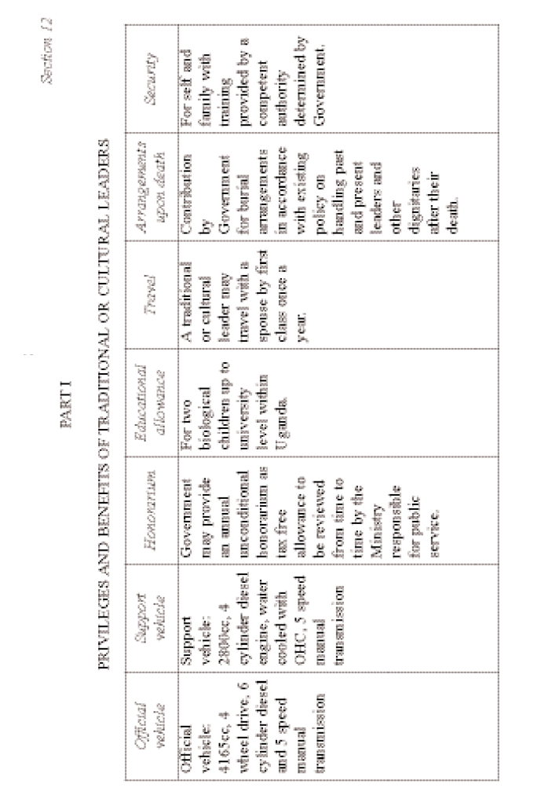
Act 6
Institution of Traditional or Cultural
Leaders Act
2011
IN
.v
:V
:V
£
■l¹:
I . :
■_{r}.  Q H 1  H  a | L _ 5  i, 8 „ - : E . V = a .. ^{i:} 5 1 ft % § ZS  £ & P 5 “ “  rn 5 v ^{w} i >_■ to U- D? J_ u-
■■ _{s}  5 5 a 1 •! 11 | « 4* ■>  ■- ■,■ ■s - ^ ■■ _{t}  ^ i r L  .- C ~ :: —
■ ■ 5'  | 11 3 | ■ ■■  ■■■ ■ | “ ^ i=  : I I  ^{L} ^ IP  -= Rl “■ Ea  5 y 0 * r—3 ^ B ^ ^  S i :  ft a iB lb i# u —  £ & E i £ t S
■k ^ s . § ■:  ll  1 | i_ Ll  =™ Q W- U  g ™ ft  1 i; q :■ r; £■ s j s iis  L v g " ^ :. V .- f -Z i .-
hi  ill 3 * | " :•; i .. e  u.:- ■.■■ tv _I ■—  j: St 5 ... s P-l;  I ... ■ - r ± t ■ ■:  tea V" bw tw — *v ra S Sfl -  -CJ- -u- r ■■!■ r- TF i w h j:-  S s-Ss.l^sH  w.- y — ‘-y — ^ — C y-
g * 11 ■3 1  I ^ | TH ^  t 5 :: £ - ^ s s  »„ "3 in - ■**“ «„ -ri-a —»  ^ ^ ^ ^"1 ^{s} ’E S m  6 SlE-f | S E ■£ - T? r]:. b ■:: ■- v. L — - L: - : - .■ -■ r  S ■- i r - ^ ^ ■ ; - i ^ -  &■ Tj i> ~F- -F! ;- c t 3
14

